Project Report Template

1. **INTRODUCTION**
   1. OVERVIEW

The title of the project allotted to our group is PROPERTY MANAGEMENT APPLICATION USING SALESFORCE. Property management application is about managing the properties according to the user’s satisfaction and closing the deal with loan if needed

* 1. PURPOSE

property management application is used for knowing the properties which are available sale or rent depended on user’s expectation

1. **PROBLEM DEFINITION AND DESIGN THINKING**

EMPATHY MAP

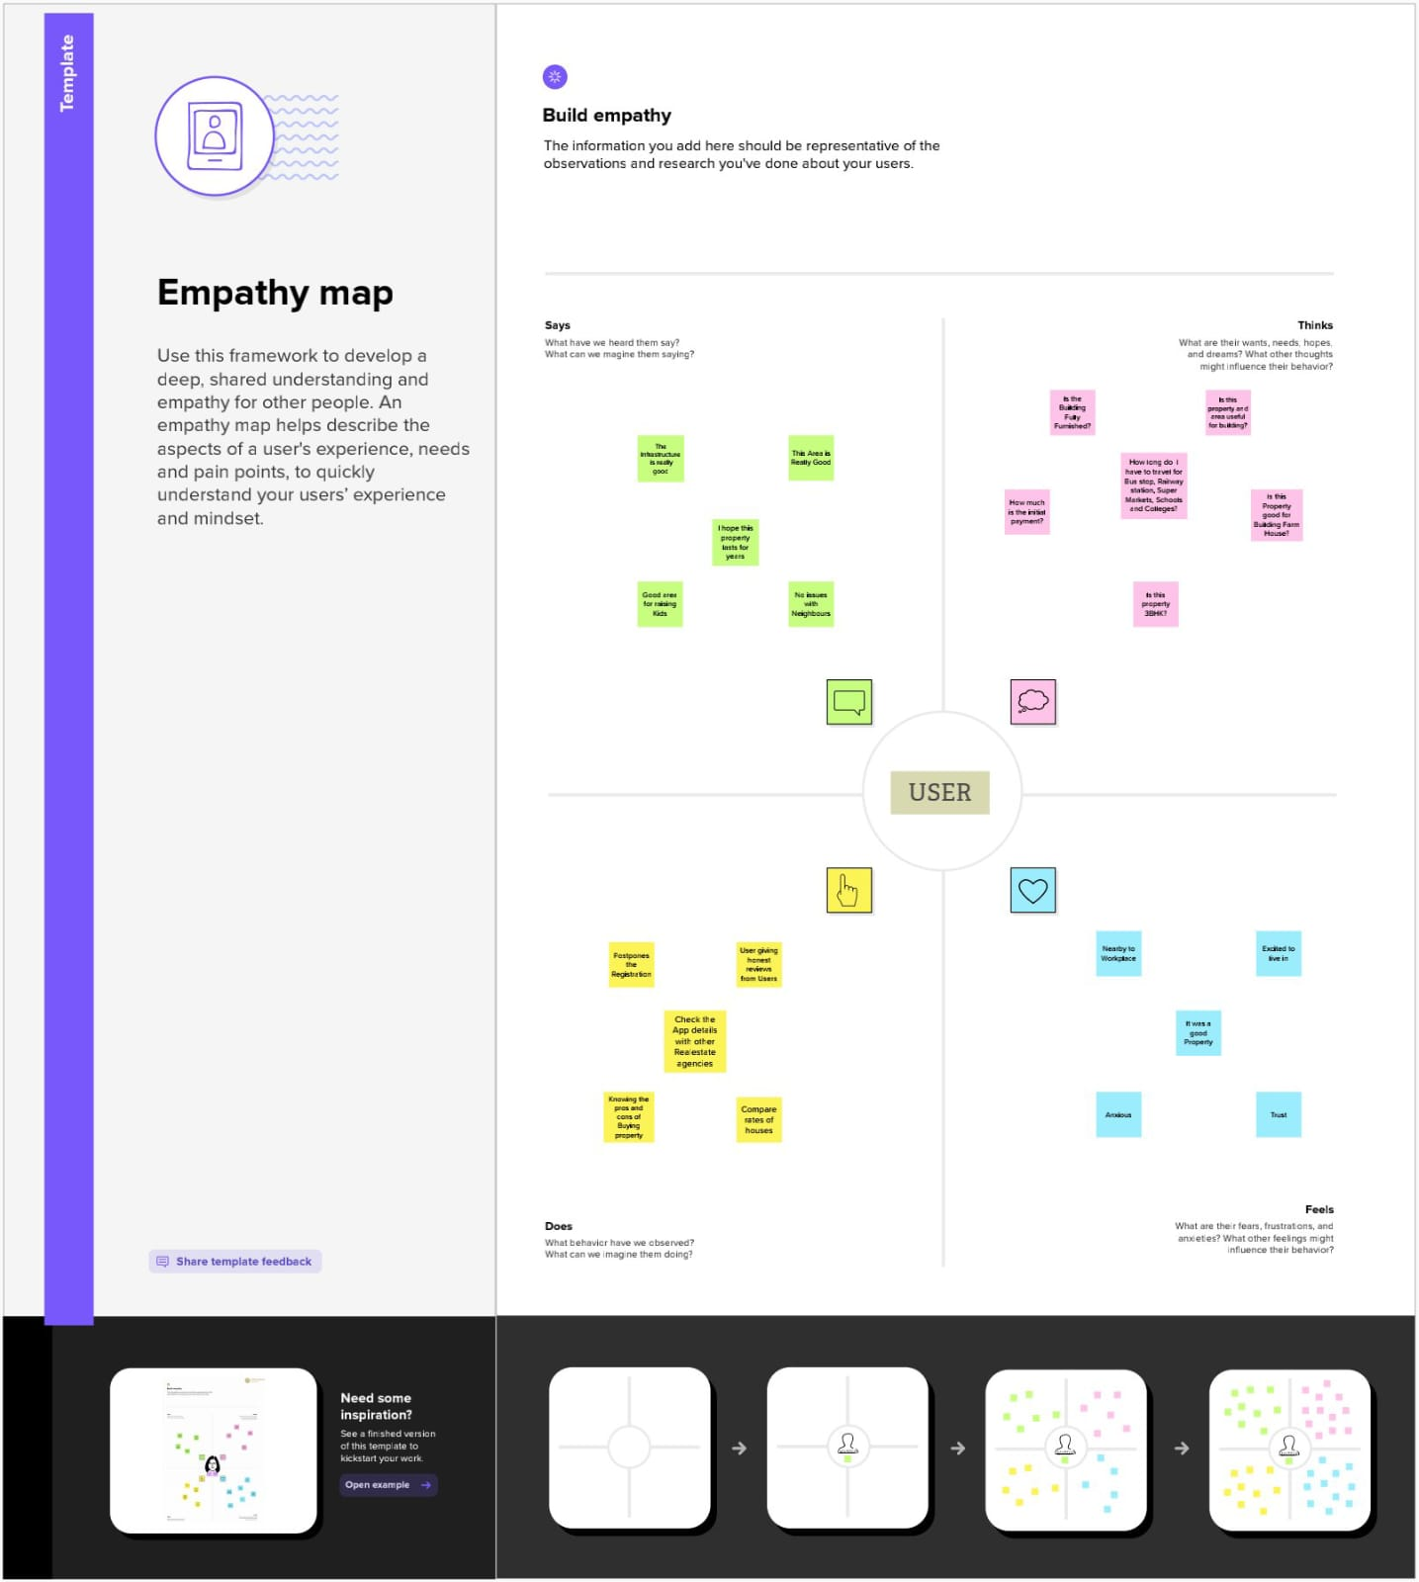

BRIAN STORMING MAP

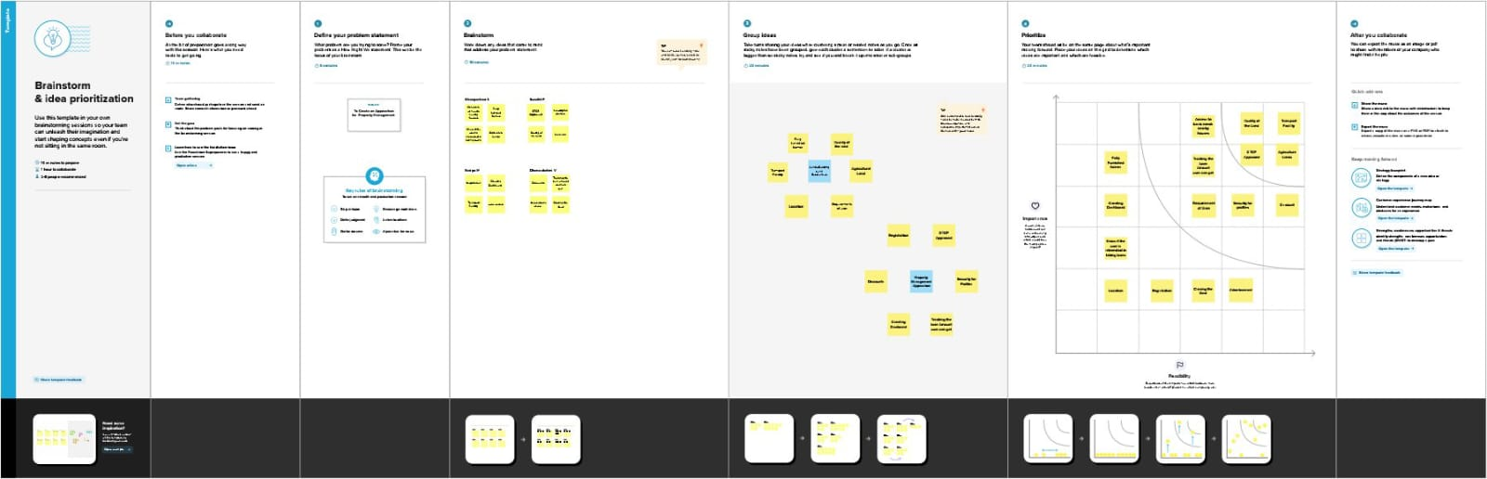

1. **RESULT**
   1. DATA MODEL

|  |  |
| --- | --- |
| OBJECT NAME | FIELDS IN THE OBJECT |
| OBJECT 1 –  LEAD | |  |  | | --- | --- | | FIELD LABEL | DATA TYPE | | LEAD | PICKLIST | |
| OBJECT 2 –  BUY | |  |  | | --- | --- | | FIELD LABEL | DATA TYPE | | BUY | PICKLIST | |
| OBJECT 3 –  CITY | |  |  | | --- | --- | | FIELD LABEL | DATA TYPE | | CITY | PICKLIST | |
| OBJECT 4 –  LOAN | |  |  | | --- | --- | | FIELD LABEL | DATA TYPE | | LOAN | FORMULA | |
| OBJECT 5 –  EMAIL | |  |  | | --- | --- | | FIELD LABEL | DATA TYPE | | EMAIL | EMAIL | |

* 1. ACTIVITY AND SCREENSHOT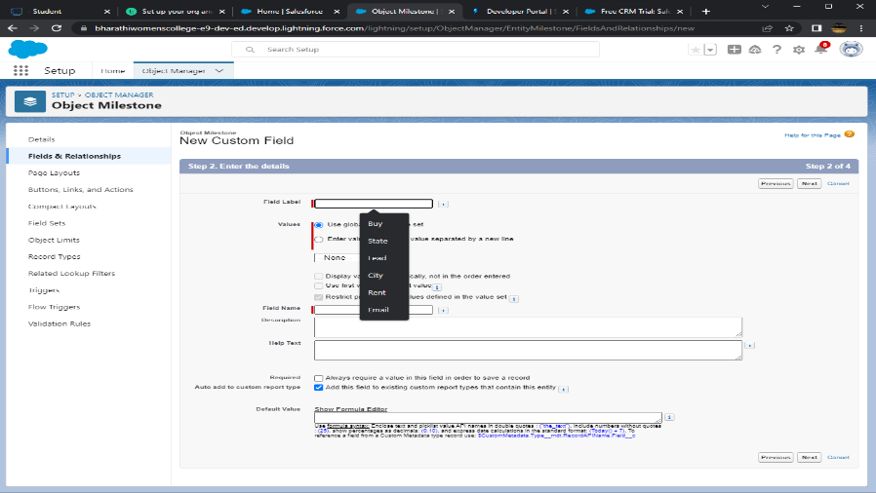

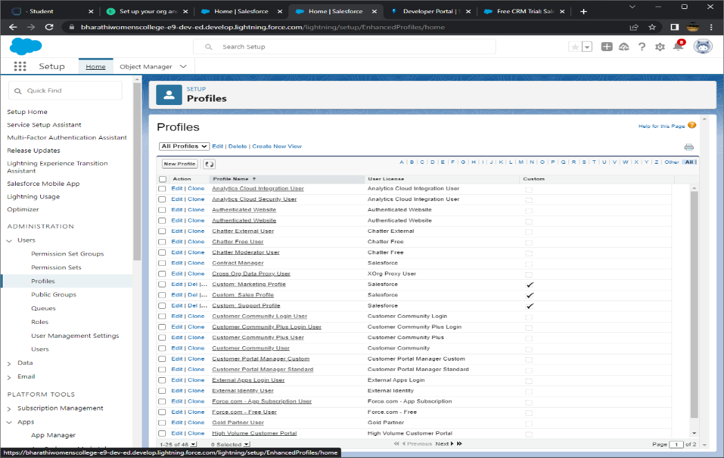

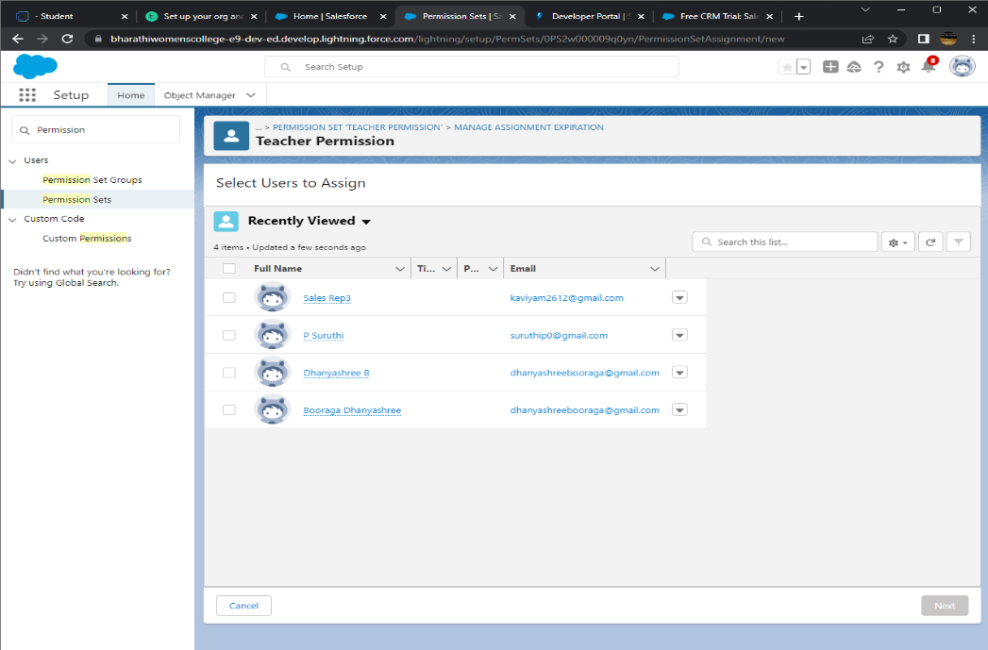

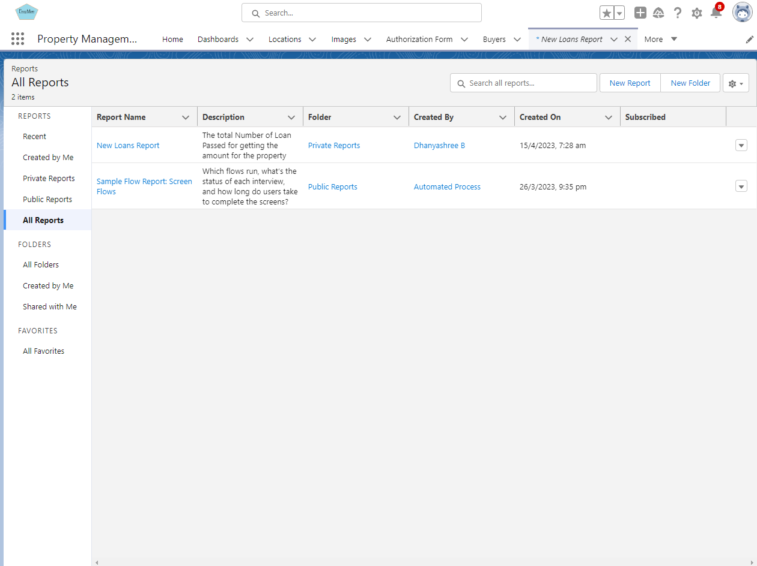

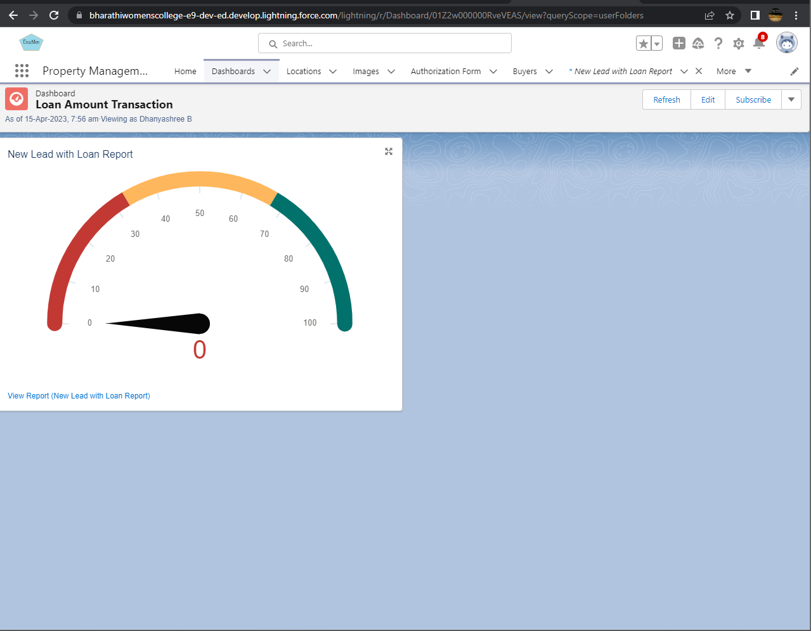

1. **TRAILHEAD PROFILE PUBLIC URL**

TEAM LEAD -SANGEETHA.T

<https://trailblazer.me/id/sangt14>

TEAM MEMBER 1 – ABITHA.R

<https://trailblazer.me/id/aabithar>

TEAM MEMBER 2- PRISCILA.R

<https://trailblazer.me/id/ppriscillar>

TEAM MEMBER 3 KARTHIKA.S

<http://trailblazer.me/id/pskarthika>

1. **ADVANTAGES AND DISADVANTAGES**

|  |  |
| --- | --- |
| **ADVANTAGES** | **DISADVANTAGES** |
| **User can select the filter the requirements** | **User cannot pick access all the resources** |
| **User can select the cities they want** | **EMI is not available in property purchase** |
| **User can pick if he/she wants to get loan** | **The App cannot show the pictures of properties** |

1. **APPLICATIONS**

* **Can Buy or Rent the properties**
* **Agricultural Lands**
* **Real Estate**

1. **CONCLUSION**

**The property management application is a system that is used to track the Available Properties and make the users get benefitted. It contains various States and cities of India.**

1. **FUTURE SCOPE**

**The Application will be Updated with various areas included Rural Areas and Urban Areas. The Properties will be Distinguished into Lands, Buildings and Agricultural areas. The payment methods will be improved. The Loan amount and payment percentage will be revised.**